Name_____________________________________________

1. **(16 pts)** Below is a phylogeny of four species based on 6 derived characters, named A, B, C, D, E.  For each of these four species, list all the characters that it has.

Species 1: ____ACD______________________________

Species 2: ____ABCDE___________________________

Species 3: ____ABD______________________________

Species 4: ____B_________________________________

1. **(3 pts)** Humans have an enolase gene and the bacterium *Escherichia coli* has an enolase gene.  If these two genes are homologous, which of the following must be true?
   1. Their last common ancestor had a gene for enolase.
   2. Their last common ancestor did not have a gene for enolase.
   3. The enolase gene evolved independently in each organism.
2. **(3 pts)** In this lab you analyzed amino acid sequences of enolase. In which other lab in BIO 1201 is enolase involved?
   1. Vertebrate Morphology Lab
   2. Paternity Testing Lab
   3. Animal Behavior Lab
   4. Cell Metabolism Lab
3. **(4 pts)** The following are trait tables for 4 hypothetical organisms. The X indicates a derived trait in the first table and the numerals in the second table indicate the number of shared traits.

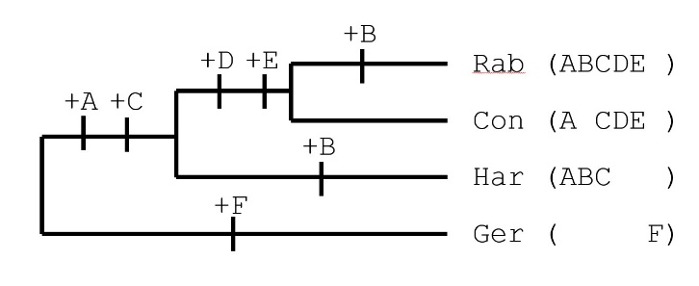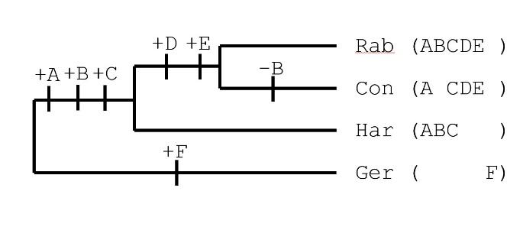**Circle the most parsimonious tree(s) from the options below, based on these tables. There may be more than one correct answer.**

**D**

**C**

**B**

**A**

1. The amino acid sequences of homologous proteins from four different plant species were aligned. Below is a small part of the aligned sequences. Suppose that you were going to analyze these sequences for a phylogenetic comparison like you did last week.

Examine the sequence alignment and then answer the questions below.

**(12 pts)** Identify the numbers for any or all amino acid positions that **provide(s) useful information** for determining the phylogenetic relationships among these four species.

2, 4, 5, 7

**(12 pts)**Identify the numbers for any or all amino acid positions that **provide(s) useful information** suggesting thatthale cress and saltwater cress are more closely related to each other than to other species.

2